PathSimR – Obstetrics Example

# Problem

## Project title & summary

**Obstetrics Hospital Pathway based on published study by Cochran & Bharti 2006** (Reference at end of document)

The paper authors were interested in a variety of insights particularly how beds could be reallocated to different areas of the pathway to reduce blocking of beds whilst maintaining bed unit utilization.

The following set of tables outlines how one of their ‘what if’ studies can be translated into PathSimR. All assumptions involved with this translation can be found in the Assumptions and Limitations section of this document.

## Key PathSimR Features

* Zero length internal queue system leading to potential capacity driven delays (blocking after service)
* Rejection at full external queues (patients will be lost if there is no space upon arrival from outside the system)
* Multiple external arrival points, each with a unique arrival rate
* Small cycles within the network

## Summary of services along patient pathway

|  |  |  |
| --- | --- | --- |
| Service Point | Service Point Type | Description |
| Triage | Bedded Unit | * Capacity: 10 Beds * Average LoS: 3.2 Hours * Modelled as a log-normal Distribution with logmean=0.97 and logsd =0.51 |
| Ante Partum Monitored (APM) | Bedded Unit | * Capacity: 16 Beds * Average LoS: 126.34 Hours * Modelled as a log-normal Distribution with logmean=4.831 and logsd =0.1257 |
| Ante Partum Not Monitored (APNM) | Bedded Unit | * Capacity: 14 Beds * Average LoS: 126.34 Hours * Modelled as a log-normal Distribution with logmean=4.831 and logsd =0.1257 |
| Labour & Delivery (LD) | Bedded Unit | * Capacity: 26 Beds * Average LoS: 8.01 Hours * Modelled as a log-normal Distribution with logmean=2.008 and logsd =0.3818 |
| Post Partum (PP) | Bedded Unit | * Capacity: 48 Beds * Average LoS: 46.71 Hours * Modelled as a Gamma Distribution with shape=4.831 and rate =0.0738 |
| Recovery PACU (PACU) | Bedded Unit | * Capacity: 6 Beds * Average LoS: 3.5 Hours * Modelled as a Uniform Distribution with min=3 and max=4 |
| Medical/ Surgical Women (MSW) | Bedded Unit | * Capacity: 30 Beds * Average LoS: 68.51 Hours * Modelled as a log-normal Distribution with logmean=4.219 and logsd =0.1252 |

## Summary of exits from patient pathway

|  |  |  |
| --- | --- | --- |
| Exit | Possible Discharge Delay | Description |
| Home | No Delay | Only exit in pathway |

## External arrival rates to the patient pathway and queue capacity

|  |  |  |
| --- | --- | --- |
| Service Point | Arrival Rate Estimation | Queue Capacity |
| Triage | 1.64 per hour | **External:** 9999  **Internal:** 0 |
| Ante Partum Monitored (APM) | 0.008 per hour | **External:** 9999  **Internal:** 0 |
| Ante Partum Not Monitored (APNM) | 0.006 per hour | **External:** 9999  **Internal:** 0 |
| Labour & Delivery (LD) | 0.333 per hour | **External:** 0  **Internal:** 0 |
| Post Partum (PP) | N/A | **External:** 0  **Internal:** 0 |
| Recovery PACU (PACU) | N/A | **External:** 0  **Internal:** 0 |
| Medical/ Surgical Women (MSW) | 0.135 per hour | **External:** 0  **Internal:** 0 |

## Features of the patient pathway

|  |  |  |
| --- | --- | --- |
| Service Point | Onward Service Points or Exits | Additional Information |
| Triage | APM: 1.62%  APNM: 1.38%  Labour & Delivery (LD): 38.5%  Home: 58.5% |  |
| Ante Partum Monitored (APM) | Labour & Delivery (LD):50%  Home: 50% |  |
| Ante Partum Not Monitored (APNM) | Labour & Delivery (LD):25%  Home: 75% |  |
| Labour & Delivery (LD) | APM: 7%  APNM: 3%  Post Partum (PP): 64.97%  Recovery PACU (PACU): 24.03%  Medical/ Surgical Women (MSW): 1% |  |
| Post Partum (PP) | Home: 100% |  |
| Recovery PACU (PACU) | Home: 100% |  |
| Medical/ Surgical Women (MSW) | Home: 100% |  |

## Assumptions and limitations

PathSimR implements the following assumptions into the model:

* Allows for blocking after service (capacity driven delays) whereby a patient cannot move onto the next unit until a space becomes available. They therefore remain in their current location, stopping a new patient taking their place. This is not readily implemented in the paper and therefore represents a deviation in approach.
* Zero length queues around the Labour and Delivery Unit to represent the inability of a patient to wait without being in a treatment point. Triage, APM and APNM have queues for arrivals from outside the system which represent locations where patients are allowed to wait.
* This model has removed the NICU (New-born Intensive Care Unit) as it represents a shift in patient class (mother to child) and should be modelled separately.
* In the original study, there were multiple classes of patient in the Triage Unit, each of which had a different service length. PathSimR does not allow for patient classes and therefore a new service distribution was created that captures the range of service lengths and the number of patients experiencing them (based on data from the paper).

This pathway includes loops back from the Labour and Delivery Unit to the Ante Partum Units. These loops are modelled in the simulation but have an impact on the reliability of the Patient based metrics in the outputs. It is therefore advised that the user only investigate the service point based metrics (Occupancy, Queue Length, # Experiencing Capacity Driven Delays etc.) when there is a loop in the system. Moreover, in high demand cycles, the model could seize up in deadlock if two patients try to simultaneously move between the same pair of service points (i.e. each is occupying the capacity the other is seeking to move to, and hence cannot relinquish the capacity they are using). This issue is only the case where there are service point cycles in the pathway.

Based on *Cochran, Jeffery & Bharti, Aseem. (2006). Stochastic bed balancing of an obstetrics hospital. Health care management science. 9. 31-45. 10.1007/s10729-006-6278-6.*

# Inputs

## Pathway Figure

Entering the pathway information above into the PathSimR Pathway Wizard, a set of model inputs and a pathway visualisation were automatically created. The pathway diagram (a static version of the tool output is presented in figure 1) serves as a sense check on whether the inputs have been entered correctly, and can inform discussion about what parameters or service point configurations might be varied in what-if analysis.

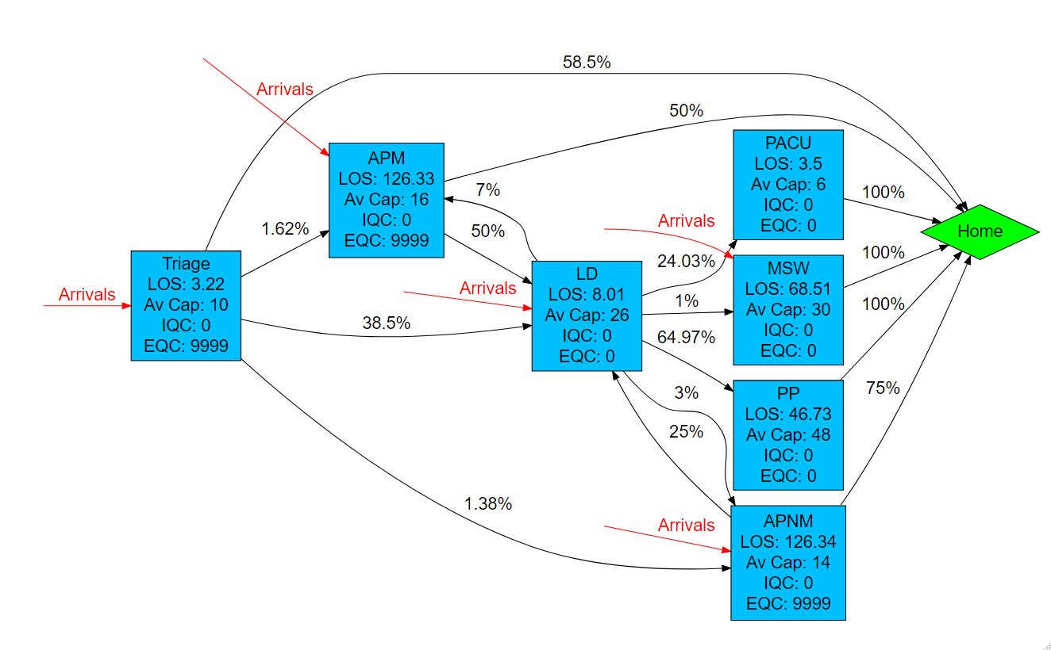

Figure

## Input templates

The Pathway Wizard also creates the following two parameter dataframes, which are used to generate the simulation. If the user has entered the data directly into the Pathway Wizard, it can be passed straight to the simulation model without the need for the user to interact directly with these files – but they can be downloaded and saved, then subsequently re-uploaded to PathSimR if the user wishes to run the simulation again without having to re-enter data into the wizard, or if they wish to make changes to specific parameters (e.g. for sensitivity analysis, or “what-if” comparison on the effect of different capacities in given service points).

***Network template***

This template, and extract of which is shown in figure 2, includes transition rates between individual service points and exits, as well as service time parameters and permitted queue lengths for each service point. Note the service points each appear multiple times in the column headers, and the table is truncated at the right.



Figure

***Calendar template***

This template, shown in figure 3, includes the arrival schedule (times and associated arrival rates – possibly zero) and the capacity for each service point with a defined capacity and service time.



Figure

# Outputs summary

Simulation results for the system described above show a bottleneck at “APM” (occupancy is greater than 15 – so the service point is effectively full and unable to receive new arrivals or transfers – more than 20% of the time, with an average occupancy of 13.24) and conversely substantial under-utilisation at “MSW” (occupancy less than 18.16 patients 99% of the time, mean occupancy 10.10, and maximum occupancy during simulation of 23 patients, against a maximum capacity of 30).

There is also evidence of more under-utilisation at both “LD” (occupancy less than 16.66 patients 99% of the time, average occupancy 8.8 patients, and maximum occupancy during simulation of 25 patients, against a maximum capacity of 26), and to a lesser extent at “PACU” (occupancy less than 3.43 patients 99% of the time and a mean occupancy of 0.91 patients, against a maximum capacity of 6).

The numerical results are summarised in figure 4 below, and a plot of the results for all service points is shown in figure 5.

**Numerical occupancy summary**

|  |  |  |  |  |  |  |  |  |
| --- | --- | --- | --- | --- | --- | --- | --- | --- |
|  | **Occupancy percentile** | | | | | | **Average occupancy** | **Maximum capacity** |
| **node** | **80th** | **85th** | **90th** | **95th** | **99th** | **100th** |  |  |
| **Triage** | 7.14 | 7.7 | 8.43 | 9.27 | 9.85 | 10 | 5.58 | 10 |
| **APM** | 15.41 | 15.56 | 15.7 | 15.85 | 15.97 | 16 | 13.24 | 16 |
| **APNM** | 9.6 | 10.23 | 11.07 | 12.14 | 13.51 | 14 | 7.56 | 14 |
| **LD** | 10.85 | 11.55 | 12.44 | 13.8 | 16.66 | 25 | 8.80 | 26 |
| **PP** | 34.86 | 35.99 | 37.38 | 39.63 | 43.38 | 48 | 30.73 | 48 |
| **PACU** | 1.18 | 1.48 | 1.78 | 2.28 | 3.43 | 6 | 0.91 | 6 |
| **MSW** | 12.33 | 12.95 | 13.78 | 15.03 | 18.16 | 23 | 10.10 | 30 |

Figure

**Graphical occupancy summary**

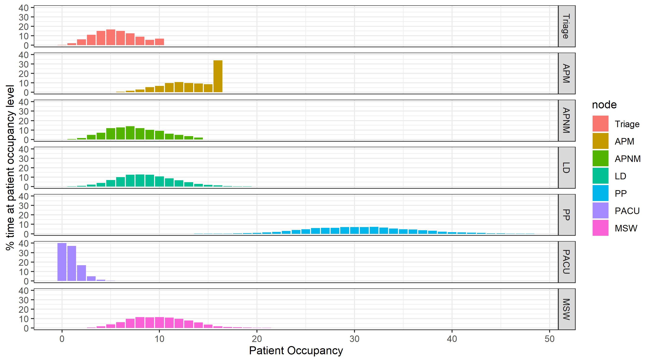

Figure

The bottlenecks described above give rise to capacity-driven delays (blocking after service) at “Triage” (average number of patients concurrently delayed 0.25, with more than 5% of the time there being more than 1.21 patients delayed), and at “LD” (average number of patients delayed 0.57, with 20% of the time there being on average more than 0.36 patients delayed, and 1% of the time more than 5.88). Both of service points are upstream from the bottleneck at “APM”, which is likely the main contributor to their delays.

There is a small amount of queueing at “Triage” (less than 2.52 patients 99% of the time, mean over simulation period 0.09) and “APM” (less than 0.93 patients 99% of the time, mean 0.06) and a negligible amount at “APNM”.